TYPICAL ASSEMBLY
CORROSSION PROTECTION

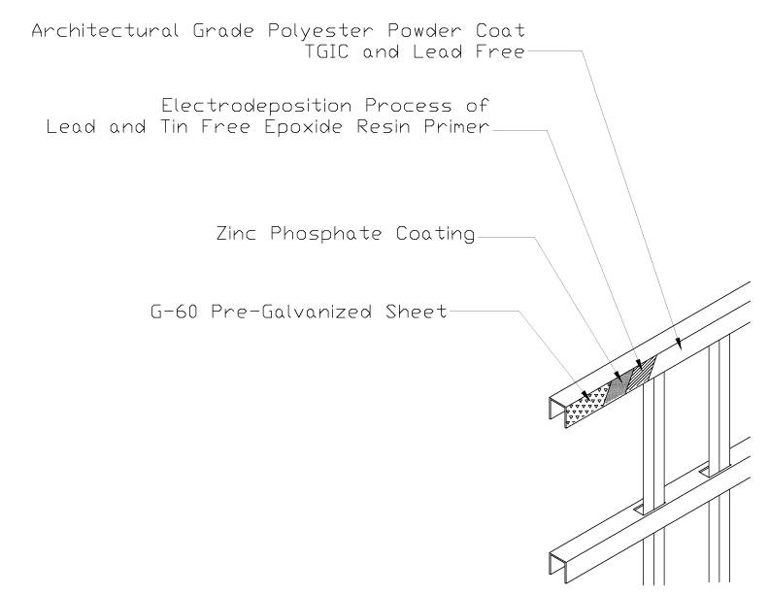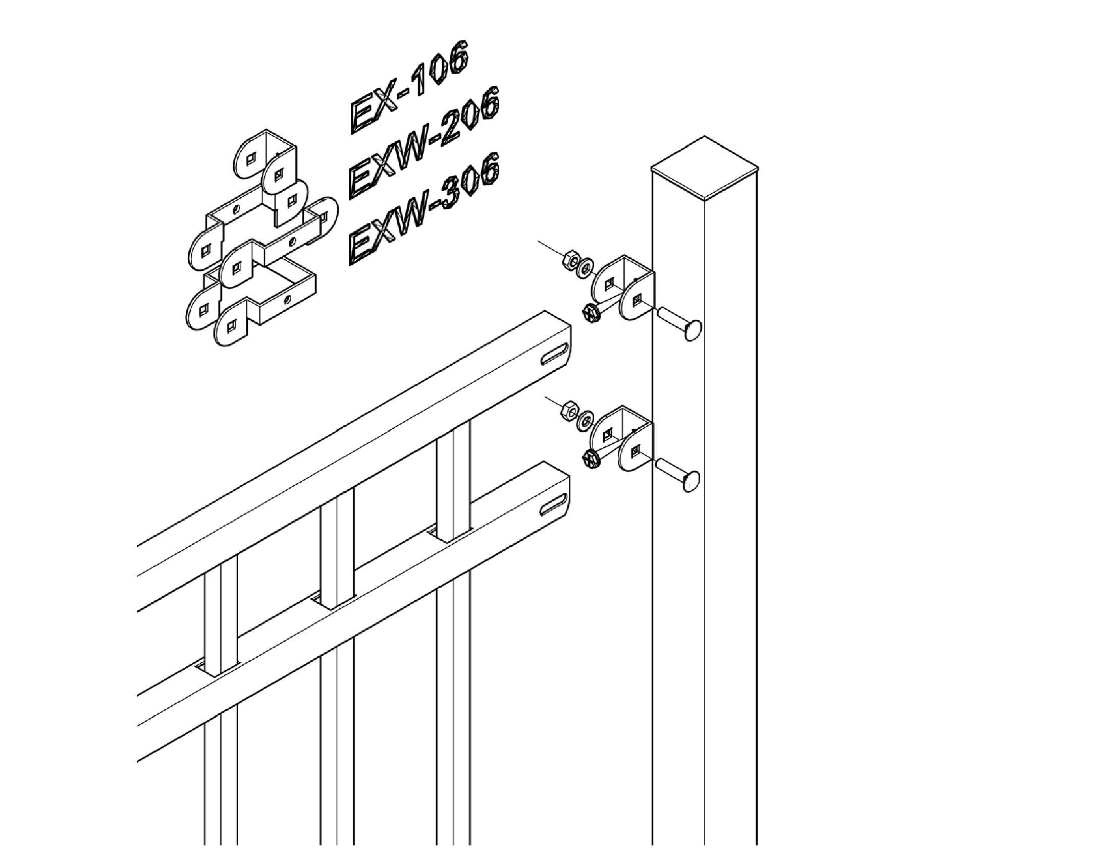
PART 1 GENERAL

  - SECTION INCLUDES:
Ornamental Rackable welded steel fence system.

1.02 RELATED SECTIONS:
Section 0503__ Metal Finishes
Section 0330__ Cast in Place Concrete.
Section 0420__ Unit Masonry.
Section 3130__ Earthwork.
Section 3231__ Paving and surface improvements.

  - REFERENCES:
ASTM-F593-02e2_ Stainless Steel Fasteners
ASTM A500__ Seamless Grade A metal tubing
ASTM A123__ Hot dip electroplating
ASTM E935__ Cone Penetration test (Method D)
In-fill Load Test (Method C)
Vertical Concentrated Load Test (Method B)
Horizontal Load Test (Method A)
ASTM B117-97__ Salt Spray Corrosion test
AC174– Section 4.2.2 In-Fill Load Test
Section 4.2.3 Uniform Load Test
Section 4.2.4 Concentrated Load Test
ICBO UBC-97__ Quality standards
BOCA__ National Building Codes

  - WARRANTY
Fortress Iron’s VERSAI products include a 20-year limited warranty, from the date of purchase, for defects in material and workmanship, including protection against cracking, peeling, blistering and corrosion (rusting). Refer to 20 Year Warranty Sheet.

PART 2 PRODUCTS

2.01 MANUFACTURER
Fortress Iron Railing and Fence Systems
1800 Jay Ell, Suite 200
Richardson, Texas 75081
Phone: 866-323-4766 Fax: 972-644-3720
Web site: www.fortressfence.com
E-Mail: specifications@fortressfence.com

2.02 MATERIALS
Rails are Grade A cold rolled steel formed U-Channel and Pickets are Grade A cold rolled steel formed and welded tubing, both conforming to ASTM A500 with G 60 zinc coating (0.60 oz/ft²) total inside and outside surfaces in accordance with the ASTM A123 hot dipped electroplating process. Materials also conform to ASTM E935 testing (Methods A, B, C and D) and load testing in accordance with AC174 (Sections 4.2.2, 4.2.3 and 4.2.4).

  - COMPONENTS
Rails: 14-gauge formed U-Channel ASTM 500 galvanized steel, 1-9/16-inch Leg X 1 3/16 inch Web.
Pickets: 16-gauge ASTM A500 galvanized welded and formed steel tubing for 4’ 5’ & 6’ tall panels,14-gauge ASTM A500 galvanized welded and formed steel tubing for 7’ & 8’ tall panels 3/4-inch square.
Posts: 16-gauge 2 1/2-inch square, 14-gauge 2 1/2inch square, 14-gauge 3-inch square. ASTM A500 galvanized formed and welded steel tubing with powder coated factory finish. Post caps can be pressed steel dome.
Fasteners: All nuts, bolts, sheet metal and wood screws are stainless steel conforming to ASTM F593-02e2 standard.
Fittings: Fabricated tees, elbows, splice connections; wall returns, wall ends and other similar components are of the same material, specification and finish as fence panels.

2.04 STYLE
Fortress Iron’s Versai Fence is made in four (5) styles:
Curved Top (CT) Flat Top, Extended Bottom (FT), Extended
Top, Extended Bottom (EXT), Spear Point Top,
Extended Bottom (SP), and Flat Top, Flat Bottom (PL) for
Swimming Pool installations.

2.05 FABRICATION
A. Commercial Fence panels are fabricated in standard length of 90 1/2” and standard heights of 46”, 58”, 70”, 82” and 94” except for the PL panel which is 54” in height to meet Swimming Pool codes. All fence panels comply with all requirements indicated for materials, thickness, design and details of construction.
B. All welded connections comply with AWS standards for recommended practice in shop welding.
C. All components are accurately cut and drilled to receive hardware, fasteners and accessories.
D Panels shall be capable of supporting a 300 lb. load (applied at midspan) without permanent deformation. Panels shall be rackable to a 30” change in grade.

2.06 FINISH
A. Metal parts are assembled and finished individually prior to shipment.
B. Galvanized steel fence components are cleaned with a non-petroleum solvent followed by the application of a sealing zinc phosphate coating.
C. Immediately after sealing, a two-step finishing process consisting first of an electrostatic dipping process in a lead free high corrosion resistant epoxy resin leaving a coating of approximately 20 microns followed by a thermosetting carboxyl polyester resin top coat with a minimum dry film thickness of 60 to 70 microns. The second coating will be applied by the electrostatic spray process.

PART 3 EXECUTION

3.01 PREPARATION
Stake layout showing locations of all gates and posts. Contact “CALL BEFORE YOU DIG” prior to beginning any excavation work.

3.02 INSTALLATION
A. Install fences in accordance with written instructions and in accordance with authorities having jurisdiction.
B. Concrete Set Posts: Drill hole in firm soil. Posts holes will be a minimum of 24 inches deep with a minimal diameter of 8 inches. Fence post (2 ½”) shall be spaced 95” on-center to accommodate installation of brackets on 2 ½” post.
C. Installation is to conform to the specifications referenced in Section 1.02 of this specification.
D. Install Fortress brackets onto fence section and posts as indicated in printed instructions for specific fence style. Attach fence sections to brackets with approved fasteners and techniques to insure that fence sections are parallel to grade within ¼-inch in 12 feet.
E. Gate Installation: Install in accordance with printed instructions. Do not mount gate from wall of a structure. Provide gate post on both sides of a gate. For double drive gate installation, provide concrete center drop to foundation depth and drop rod retainers at center. Lubricate to insure smooth operation and verify proper latch operation.

  - CLEANING

- Remove all cutting and drilling chips that are attached to the fencing, post, brackets or additions to prevent corrosion.
- Repair scratches and other installation-incurred damage. Using a spray paint of the appropriate color that includes a zinc additive, repaint and seal any scratches or holes drilled in the fencing, post, brackets, or additions to prevent rust from forming.
- Clean up debris and unused material, and remove from site.

